

Safety
We love our American traditions, and that includes Independence Day celebrations complete with fireworks. But we can't forget that fireworks are explosive, incendiary devices. In other words, they're small bombs! Nothing that kids should be fooling around with—and nothing for adults to take lightly, either.

The U.S. Consumer Product Safety Commission reports that some 11,000 people went to the emergency room in one recent year with fireworks-related injuries. According to Prevent Blindness America, a national organization dedicated to preventing eye injuries, there is no safe way for nonprofessionals to use fireworks. At the very least, “Do not let your child play with fireworks,” say the experts at PBA. “Do not use them yourself, and keep family members away from those who do.” Here are some startling statistics about injuries from consumer fireworks:
- Prevent Blindness America reports the highest injury estimates are: firecrackers (24%),
rockets (20%), and sparklers (18%).
- Almost half (48%) of the injuries were to children under the age of 15.
- Sparklers can heat up to 1,800 degrees Fahrenheit, hot enough to melt gold.
- Parts of the body most often injured are the

eyes (30%), hands (29%), and head/face (17%).
- Data from the U.S. Eye Injury Registry shows that bystanders are more often injured by
fireworks than operators themselves.

Of course, there are always some celebrants who want to give their own fireworks displays. If you decide to do so, be aware that many municipalities prohibit consumer fireworks and most limit the days and times that they can be ignited. Know the regulations for your neighborhood and then follow these safety precautions.
- Always read the directions and warning labels on fireworks. If a device is not marked
with the contents, directions, and a warning label, don’t light it.
- Don’t wear loose clothing.
- Supervise children around fireworks at all times.
- Never allow young kids to handle fireworks. Responsible teenagers can help with proper training and close adult supervision.
Light only one firework at a time.
- Stand several feet away from fireworks once they are lit. If a device does not go off, don’t stand over it to investigate. Douse it with water, and dispose of it.
- Light fireworks in open areas away from
July 2010

onlookers, structures, and shrubbery.
- Never light fireworks indoors or near dry grass.
- Always have a fire extinguisher nearby.
- Have a hose handy to put out fires and a water bucket to douse duds before throwing
them away.
Have a safe and happy 4th of July. We have so much to celebrate!
Birthdays 

July
2 Shaun Buckley
5 Brittney Spurlock
8 Ralph Schaeffer
10 Julie Blanchard
12 Greg Lincoln
14 Richard Farmer
14 Dean Harriman
15 Linda Weisberg
18 Terry Parmley
20 Vicky Rozis
31 Chris Riddle
31 Matt Mifflin

August
15 Doug Smith
17 Bruce Freeman
23 Toni Adams
24 John Strand
24 Les Bouck
25 Curtis Watson
27 Troy Lowery

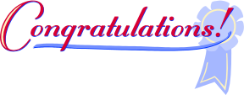
Anniversaries
10 Years:
Ron Durst (July)

5 Years:
Steve Bueler (July)
Ned Moore (July)
Davin Chea (Aug)
John Wildt (Aug)
Lance Vann (Aug)



2010 Calendar of Events
AUGUST
Summer Picnic
Sunday, 8/8
10:00am-2:00pm
Cottage Lake Park, Woodinville

SEPTEMBER
Golf Tournament
Sunday, 9/12
7:00am-2:00pm
Harbour Point Golf Course

OCTOBER
Trick or Treat Party
Thursday, 10/28
3:00pm-5:00pm
UMC

DECEMBER
Santa Party
Thursday, 12/9
5:00pm-7:00pm
UMC

JANUARY, 2011
Holiday Party
Saturday, 1/15
6:00pm-Midnight
Lynnwood Convention Center

New Hires
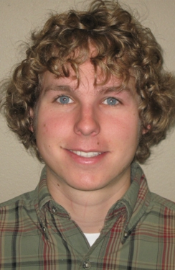
Keegan Hollister started working for UMC on 6/7/10 as a Project Engineer reporting to Troy Lowery. He just graduated with a degree in Mechanical Engineering from Washington State University. He enjoys snowboarding and working on motorcycles and cars.


Lauren Smith started working for UMC on 6/14 as an office assistant to Brett Endres and the Detailing Dept. Lauren worked for UMC last summer before she started college at Santa Clara University (CA). Lauren enjoys gymnastics and swimming.

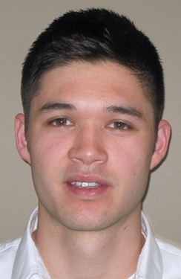
Justin Pritchett started working for UMC on 6/14/10 as a student intern. He is currently a junior in the Construction Management Program at Central Washington University. Justin is an active member of the MCA at CWU. He enjoys wakeboarding, basketball, and other physical activities.

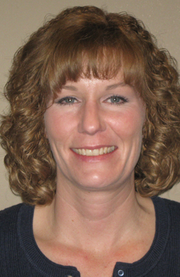
Elizabeth “Liz” Spell became an "official" UMC employee on 6/28/10. Liz started working for UMC through Aerotek in January as an Administrative Assistant in the Service Group, reporting to Rich Happel. Liz’s last position was with Michael Astrof Construction Inc., where she was the Office Manager for five years. Prior to this she was an Administrative Assistant for Press Corps Inc.; an independent sales company for Alkahn Labels Inc. Liz has nearly sixteen years of office and administrative experience. Liz enjoys exercising, gardening, reading, and spending time with her husband and daughter.

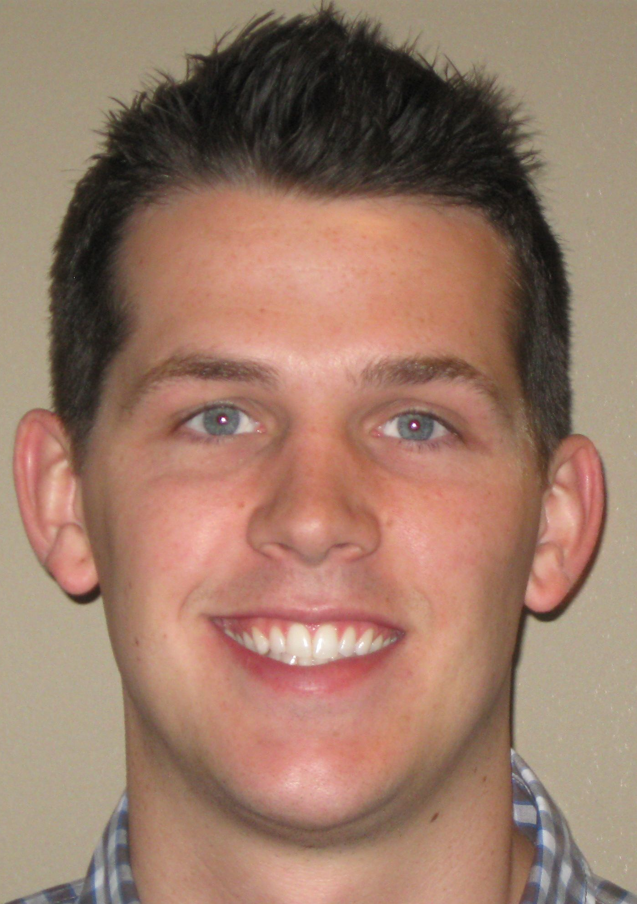
Joseph Berger started working for UMC on 6/29/10 as a Project Engineer reporting to Matt Thibeau. He is a recent graduate of the University of Washington’s Construction Management program. He was active in the MCA Student Chapter and participated in the national MCA student competition. Joey enjoys traveling.
STAR Performer –
2nd Qtr.

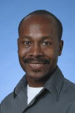
Congratulations to Kenny Zeumault as the 2nd Quarter STAR Performer. We would say that when it comes to foremen, we may have had many, but we haven’t had any quite like Kenny.

Kenny's dedication to craftsmanship, company and personal values are tough to match! He is one of the most intensely self- driven people that we have ever been around. He has a pursuit of perfection that will sometimes make your head spin. Kenny has a never-ending desire to do his best all day, every day. He has held many titles in his years with the company: foreman, general foreman, in charge of the service department, and most recently he is a material management specialist.
Everything Kenny has done has seen success as he has given his ultimate dedication and passion to be a perfectionist.

Congratulations Kenny!!

Written & Submitted by:
Matt Mifflin & Steve Otis

WHAT’S HAPPENING
AT UMC

Fabrication Shop

The UMC Piping and Plumbing fabrication shop has had a busy year providing support for all the UMC projects. With the leadership of Bruce Lincoln and Dean Harriman the shop is able to produce pretty much anything that is needed from piping, plumbing, supports, brackets, structural steel, jigs, testing equipment, custom tools and assemblies. The fabrication shop has done a good job of maintaining a very talented group of steady employees which ensures that all fabrication is done at top quality and in a timely fashion.

The piping shop has been working through its usual mix of welded pipe, support steel and assemblies. Year to date they have produced over thirty tons of support steel and 12,000 diameter inch of welds. When these two items are not keeping them occupied, they have been working hard to build large prefabricated assemblies. These large assemblies can be dropped into place fully assembled. These assemblies are allowing us to maintain construction schedules, minimize our on site crew sizes and allow the field crews to focus on more important job site work areas.

The plumbing shop has grown leaps and bounds over the last year as Bruce and his crew continue to innovate. The different methods and techniques that Bruce has developed are second to none in the industry. He has taken his many years of field expertise and applied them to the fabrication shop deliverable model. This has ensured that when a product is delivered to the field, it meets all of their needs and expectations. Bruce has great attention to detail and provides his fabrication with all the parts needed to install it, right down to the small parts zip tied to the fabrication for ease of assembly. The bulk building of standard plumbing rough in assemblies is paying dividends on the schedule side of projects and providing consistency for setting finishes.

All of these things allow UMC to provide a more consistent delivery, at a lower cost and faster than previously thought possible. The fabrication shop is a key support structure to University Mechanical Contractors Inc. Thanks to everyone involved with the fabrication shop.

Written by:
Steve Otis

Industry News
Congratulations to Ed Kommers, MCAWW Executive Director and former UMC President, who was recently nominated to the UW Construction Hall of Fame. Ed was chosen for his leadership and support of construction education. He joined 29 others who have been inducted since the program was founded in 1995.

